Saving Your Work

*Jingle Edition*

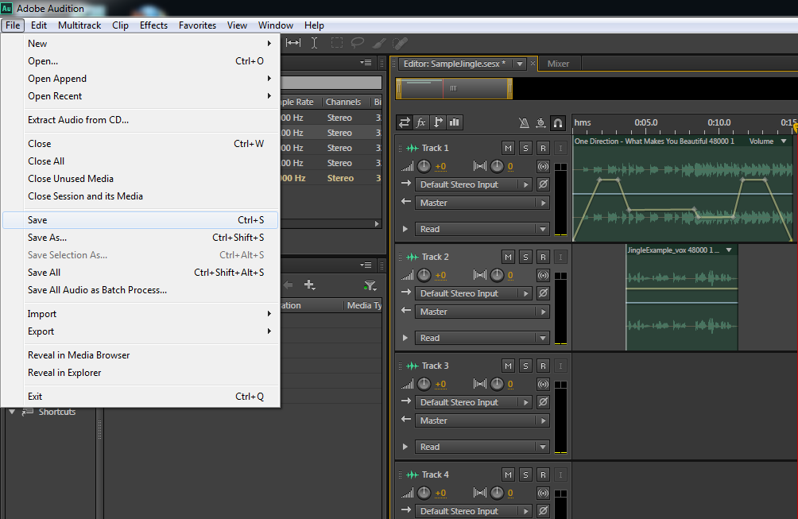

Whether you're ready to finalize your project or still working on it, make sure you are frequently **saving your session** by simply clicking "**File**" and "**Save**."

Once you are ready to finalize your work into a mixdown, you must be sure to save your session.

**1**

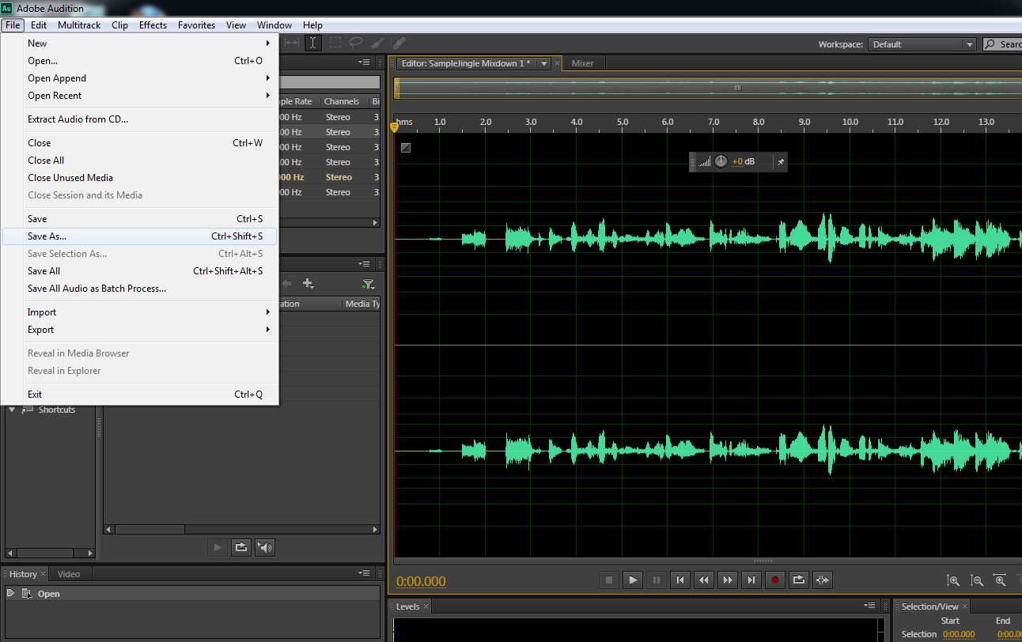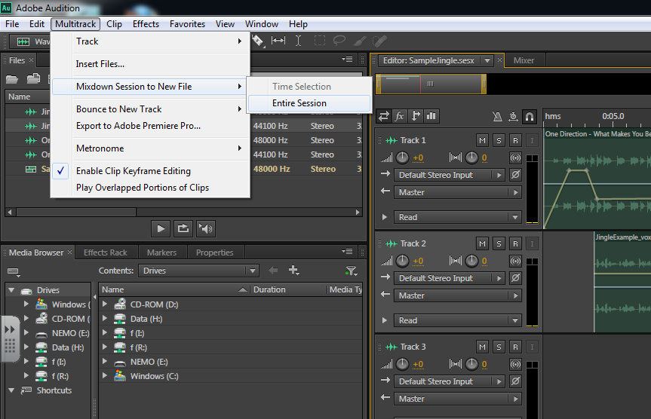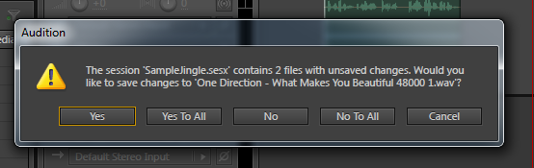

**2**

**4**

**3**

To mixdown your session into one final file, select "**Multitrack**," "**Mixdown Session to New File**," and "**Entire Session**."

This window may pop up if you've made changes to any of your audio files and have not yet saved them. Select "**Yes to All**" to avoid having it pop up several times.

Your mixdown should appear in the **Waveform** view. Once you're there, listen to it, and make sure it's exactly what you want!

Then, select "**File**" and "**Save As**."