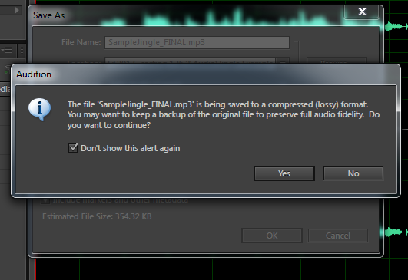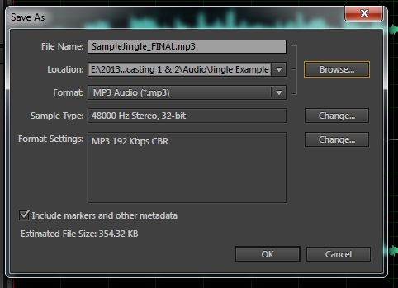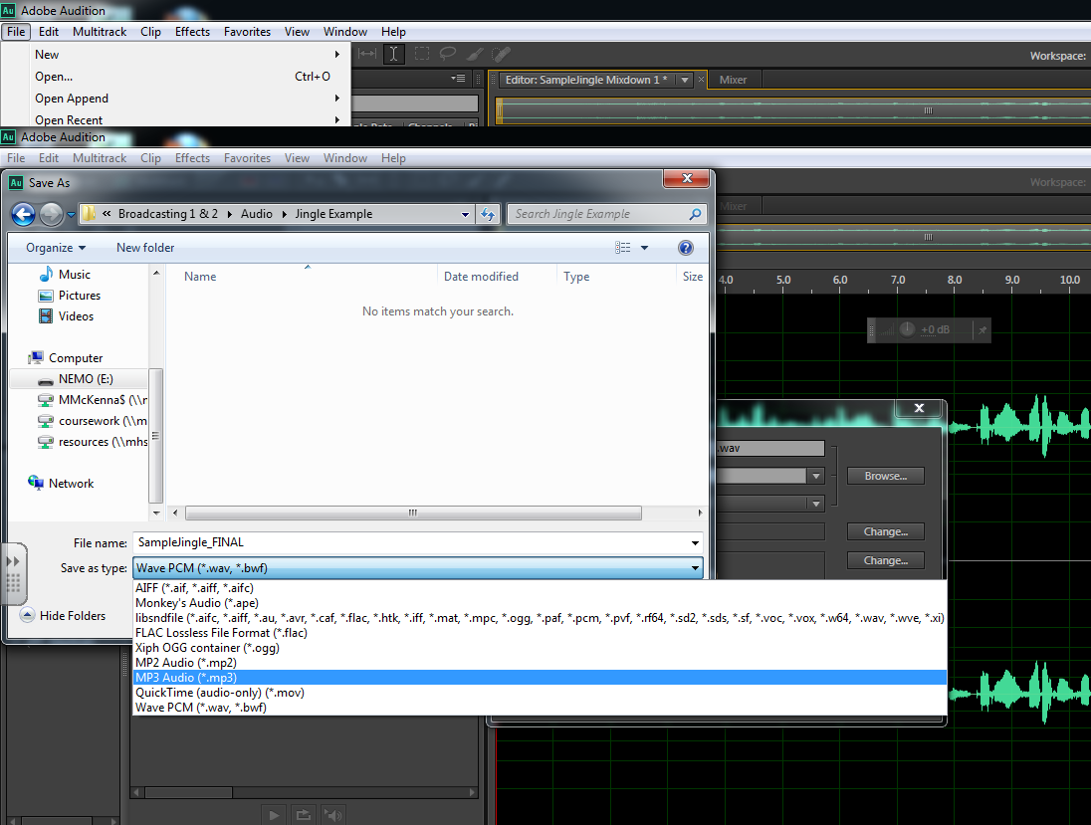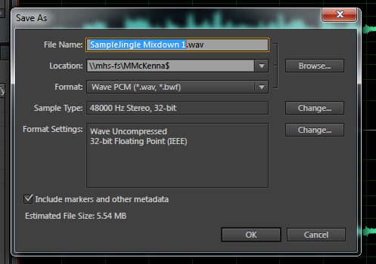

Adobe Audition may ask you a question about saving in a "**lossy**" format. Just ignore the alert, and select "**Yes**."

**8**

Make sure that you are saving the file onto your flash drive and into the correct folder. Name the file identifying the project and that it's the final mixdown.

(For example: **SunnySideUpJingle_FINAL.mp3**).

Be sure to change the audio file to **MP3**.

When this window pops open, just select "**Browse**."

**9**

**7**

**6**

**5**

The last step is to "x" out of Adobe Audition, and make sure the file is saved on your flash drive!

Next, simply select "**OK**."